**Tasks**

**Learners have to develop a dashboard to support the answers to the following questions.**

**Objective Questions:**

1. What is the total no. of tables present in the data?

Ans. Only one table is present in the dataset for analysis

___________________________________________________________________

2. What is the total no. of attributes present in the data?

Ans. There are a total of 35 attributes in the datasheet to be cleansed and analyzed.

__________________________________________________________________

3. The data consists of some inconsistent and missing values so ensure that the data used for further analysis is cleaned.

Ans. Removed a few irrelevant columns: time-duration (contains unnecessary data based on the presentation description), isWhiteListUser, and queue (both have single values).  
 Performed cleaning and extraction on the following columns: createdAt, updatedAt, chatStartTime, and chatEndTime.

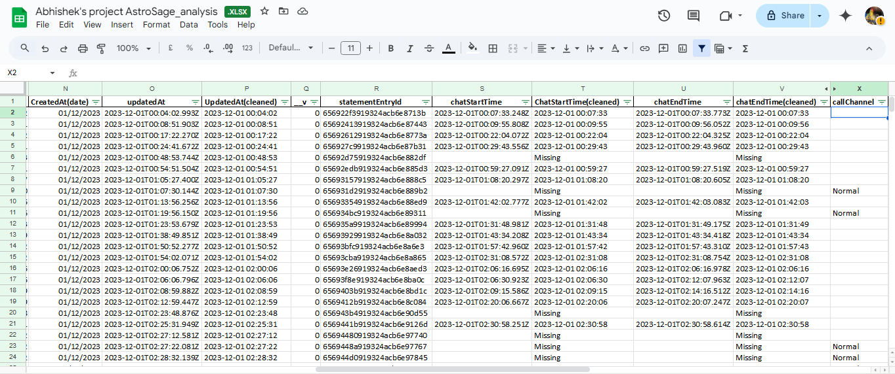

___________________________________________________________________

4. What is the change in daily call volume day by day and also find the average daily call volume.

Ans - Average Calls Per Day - 250

Average Change = 1%

Formula for Percentage Change - Percentage Change = (Previous Value Current value - Previous Value) * 100

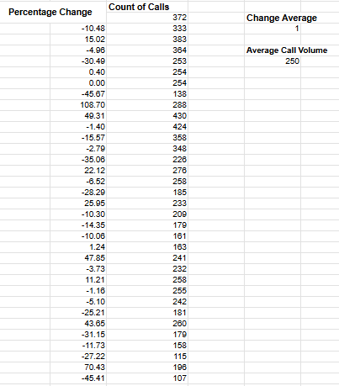

The given pivot table in the sheet named ‘Question 1-8” of the spreadsheet file summarizes the Daily call volume by grouping the days and counting the number of calls for each day.

Key insights drawn:

The data for daily calls received seems to be decreasing in the longer term and hence the stakeholders need to do something in order to prevent the daily call volume from impacting the revenue.

Suggestion:

Reason behind the decrease in call volume could be less number of new users and less retention rate(although this requires more analysis). A solution for this could be to increase spend in marketing and improvement of services.

__________________________________________________________________

5. Which months experienced the highest and lowest call volumes?

Ans- Since the data covers only a single month (December 2023 and the first three days of January 2024), calculating the trend is not feasible. However, the day with the highest call volume is 10/12/2023, with 430 calls, while the day with the lowest call volume is 3/01/2024, with only 107 calls.

This data is represented in the second column of the pivot table and can be viewed by applying the following filter to the dashboard:

⦁ Set consultation type => call only.

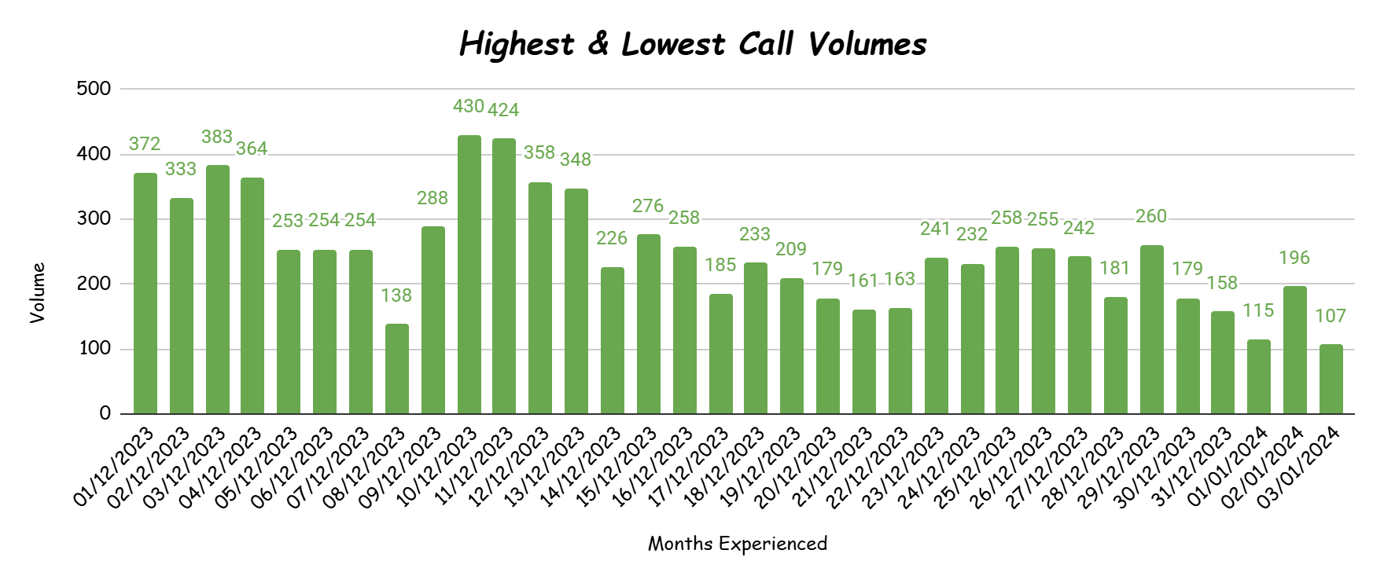

_________________________________________________________________

6- What is the total operational cost for that month?

Ans - The Astrologer’s earnings are treated as operational costs and are summed across the months.

Formula used:  
 =SUMIFS(data!AF:AF, data!O:O, "December")  
 =SUMIFS(data!AF:AF, data!O:O, "January")

| **Dec-2023** | **93786.16295** |
| --- | --- |
| **Jan-2024** | **5360.408** |

________________________________________________________________

7. What is the average number of calls handled per agent per day?

Ans- The Average call handled per agent per day comes out to be 1.91

| **Total data no. of data which data is provided** | | | | **34** |
| --- | --- | --- | --- | --- |
| **No. of Guru/Agents** | | | | **131** |
| **Total No. of Calls** | | | | **8508** |
|  |  |  |  |  |
| **AVERAGE calls handled per agent per day** | | | | **1.91** |

This was calculated by extracting the number of days, gurus/agents, and total calls. The formula used is:  
 Total calls / (Number of days * Number of gurus) = Average calls handled per agent per day.

Inference from the data:  
 An average of 1.91 calls per agent per day appears to be quite low, which may indicate a smaller user base or lower traffic. Combined with the declining daily call volume, this could signal a significant issue within the business. If this trend continues, it could have disastrous consequences for the company.

___________________________________________________________________

8. How many repeat callers are there, and what percentage of total calls do they represent?

Ans-

_________________________________________________________________

9- What are the total sales generated by the call centre for each product category?

Ans- 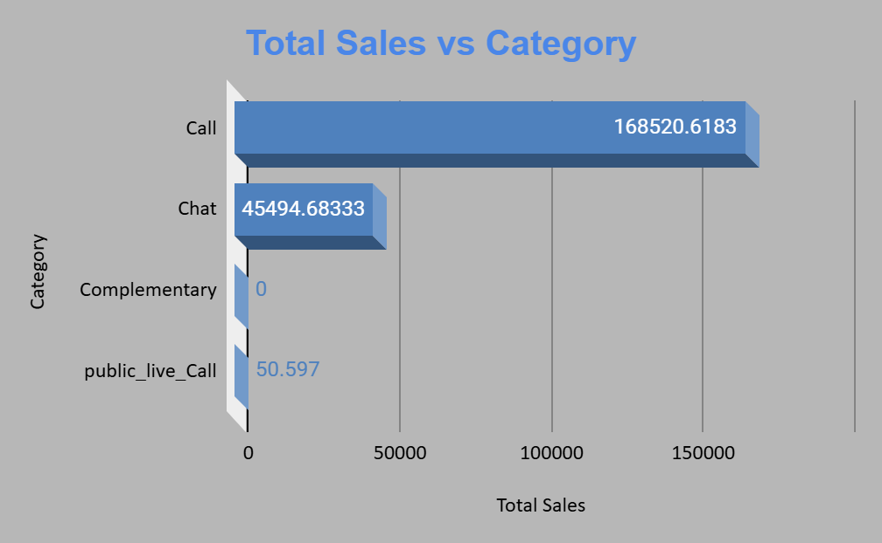

The given chart provides the required information regarding the sales generated for each product category

The chart derives its data from the below pivot table which is copied from the dashboard sheet of the spreadsheet file.

| *Category* | Total Sales |
| --- | --- |
| Call | 168520.6183 |
| Chat | 45494.68333 |
| Complementary | 0 |
| public_live_Call | 50.597 |
| **Grand Total** | **214065.8987** |

___________________________________________________________________

10- How many calls were made for each user ID and guru ID?

Ans-These two pivot tables provide data on the number of calls made by each user and the number of calls received by each agent/guru. Due to the extensive volume of this data, it is impractical to present it here.

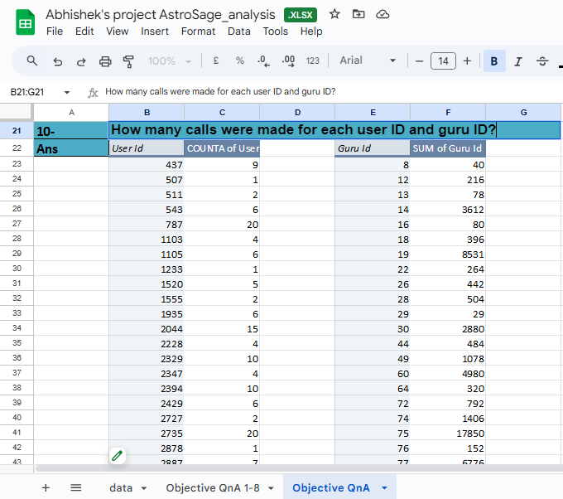

___________________________________________________________________

11- What is the correlation between call duration and customer satisfaction?

Ans- As a proper column for customer satisfaction was not available therefore considered rating as a metric to assess customer satisfaction and used that for calculation.

Formula used : CORREL(Range of UserOnCallDuration, Range of Ratings)

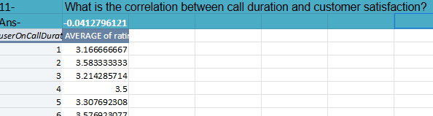

A correlation of -0.041 suggests a very weak negative correlation between the two variables being analyzed. This means:

* **Direction:** As one variable increases, the other variable tends to decrease very slightly. However, this relationship is so weak that it's almost negligible.
* **Strength:** The correlation is very close to 0, which indicates that the two variables are essentially independent of each other. Any observed trend is likely due to random chance rather than a meaningful relationship.

In practical terms, this correlation coefficient implies that knowing the value of one variable provides very little information about the likely value of the other variable.

**Key takeaway:** The two variables are almost unrelated.

_________________________________________________________________

12- Which guru has the highest and lowest customer satisfaction scores?

Ans- The guru with the highest average rating is Tarot Mystical, while the guru with the lowest average rating is Tarot Rittika.

| **Max Rating Guru** | **Tarot Mystical** |
| --- | --- |
| **Min Rating Guru** | **Tarot Rittika** |

I created a pivot table with GID as the rows and the average of the ratings as the values to evaluate the average rating for each guru/agent. I applied the Max, Min, and XLOOKUP functions to identify the GIDs corresponding to the highest and lowest average ratings. Then, I used the retrieved GIDs to look up the corresponding guru names using XLOOKUP

___________________________________________________________________

13- What is the average customer satisfaction score by month?

Ans- The average ratings for the two months are as follows: December had an average rating of 2.95, while January's average rating decreased to 2.68.

| **December** | **2.95** |
| --- | --- |
| **January** | **2.68** |

Formula used:

=AVERAGEIF(data!O:O,"December",data!AK:AK)

=AVERAGEIF(data!O:O,"January",data!AK:AK)

___________________________________________________________________

14- How many categorical columns are there in the data? [Search about categorical and continuous data, and try to answer this question]

Ans - In the provided data, the following columns appear to be categorical:

1. **user**
2. **Guru name**
3. **Guru Id**
4. **User Id**
5. **Chat Status**
6. **consultationType**
7. **website**
8. **refundStatus**
9. **freeCall**
10. **freeChat**
11. **CreatedAt(month)**
12. **UpdatedAt(cleaned)**
13. **callChannel**
14. **callIvrType**
15. **callStatus**
16. **CallSid**
17. **astrologerCallStatus**
18. **region**
19. **userCallStatus**

These columns contain non-numeric data and represent categories or labels, making them categorical variables. So, there are **19 categorical columns** in the data.

_________________________________________________________________

**Subjective Question:**

1- Should the investment be used to hire more agents, improve training programs, or upgrade call center technology?

Ans - Approach :

Check whether hiring more agents is needed : Count of guru id - I have taken a pivot table to count the guru id

Count of calls is calculated as below using countif function

=COUNTIF(data!$H:$H,"Call") + COUNTIF(data!$H:$H,"public_live_Call")

Count of days = i have calculate by fetching unique values of date and then doing count of it =UNIQUE(R2:R28028) = 34 total days

Count of calls/(count of guru id * count of days) = 1.91 Calls are handled per agent per day

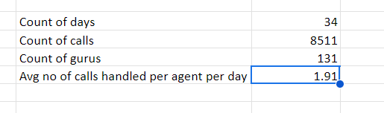

As average no of calls attended by one agent per day is 1.91 so i dont think of to hire more agents instead some agents are getting less rating so definately training programs should improve

=COUNTIF(AQ2:AQ28028,">5")

A significant portion of sessions received a rating of 0, indicating dissatisfaction or unresolved sessions.(Calculated by applying filter on ratings column)

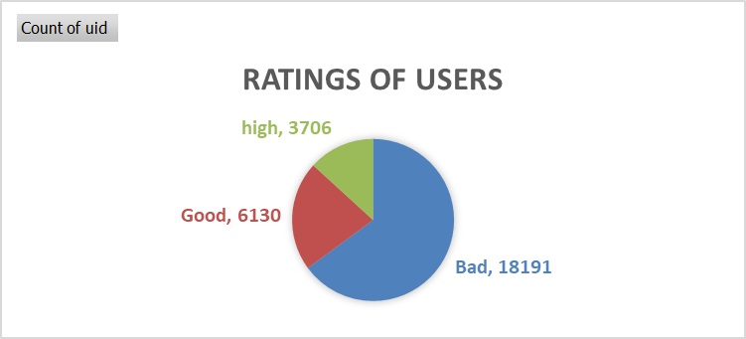

**Improving Training Programs**

There are total 28027 records and out of that only **3706** has got more than 6 and **6130** has got more than 4 rating so according to my approach

(How i have given good,bad and high rating using if formula here it is

=IF(AM2>6,"high",IF(AM2<4,"Bad","Good"))

**Insight:** Above chart shows that while some agents are performing well, a significant portion received ratings below satisfactory levels. Specifically:

* **High Ratings:** Only 3,706 sessions received a rating above 6.
* **Good Ratings:** 6,130 sessions received a rating above 4.
* **Low Ratings:** Many sessions had a rating of 0, indicating possible customer dissatisfaction or unresolved issues.

**Upgrading Call Center Technology**

* Real-time performance monitoring to manage call volumes effectively.
* Automated call distribution to ensure an even workload among agents.

**Recommedations**

* There is a clear need for improvement in training programs. targeted training can focus on agents who received low ratings to help improve their performance and customer satisfaction.

**2.** What are the potential risks of each investment option (hiring, training, technology upgrades), and how can they be mitigated? Name the chart/spreadsheet function you will use for solving the problem?

**Ans-**

**Potential Risks of Technological Upgrades:**

* Implementation Challenges: Introducing new technology can be time-consuming, and unforeseen technical issues may arise, potentially delaying or complicating the transition process.
* High Upfront Costs: Upgrading technology often involves significant initial investments, which may not generate immediate returns.

**Mitigation Strategies:**

* Phased Rollout: Introduce technology upgrades gradually to test their impact and address any technical issues before full implementation. Start with smaller teams and scale up over time.
* Cost-Benefit Analysis: Conduct a thorough cost-benefit analysis to ensure that the investment in technology aligns with the expected improvements in efficiency and profitability.

**Potential Risks with Agent Training:**

* High Costs: Comprehensive training programs can be costly, both in terms of direct expenses and lost productivity during training periods.
* Retention Issues: Trained agents may leave the company for better opportunities, resulting in a loss of investment in their development.

**Mitigation Strategies:**

* Measure Training Effectiveness: Track performance before and after training to assess its impact and continuously improve the programs based on measurable outcomes.
* Retention Programs: Offer retention incentives, such as performance-based bonuses or career development opportunities, to motivate trained agents to remain with the company.

Functions that can be leveraged to support improvements include:

**Function: WHATIF or Goal Seek  
 Use:** Assess how changes in key inputs, such as the number of agents hired/trained or the cost of technology upgrades, impact outcomes. Goal Seek can be particularly useful for identifying the breakeven point for investments, providing critical data for analysis.

**Visualization Tools:  
 Function: CHARTS (e.g., Bar Charts, Pie Charts, Waterfall Charts)  
 Use:** Display the distribution of risks, costs, and potential returns. Waterfall charts, in particular, can highlight the cumulative impact of each investment decision**.**

**___________________________________________________________________**

**3.** How does AstroSage's call center performance compare to AstroGuru's average call volume, customer satisfaction, and agent performance?

Will you use any aggregation function or a visualization here to solve the problem?

**Ans-** Data for AstroGuru is not provided for the analysis.

__________________________________________________________________

**4.** How can the call center improve its handling of peak call periods to ensure high customer satisfaction?

Mention the functionality you will use for giving the suggestions, will it be any aggregated function or a visualization?

**Ans-**

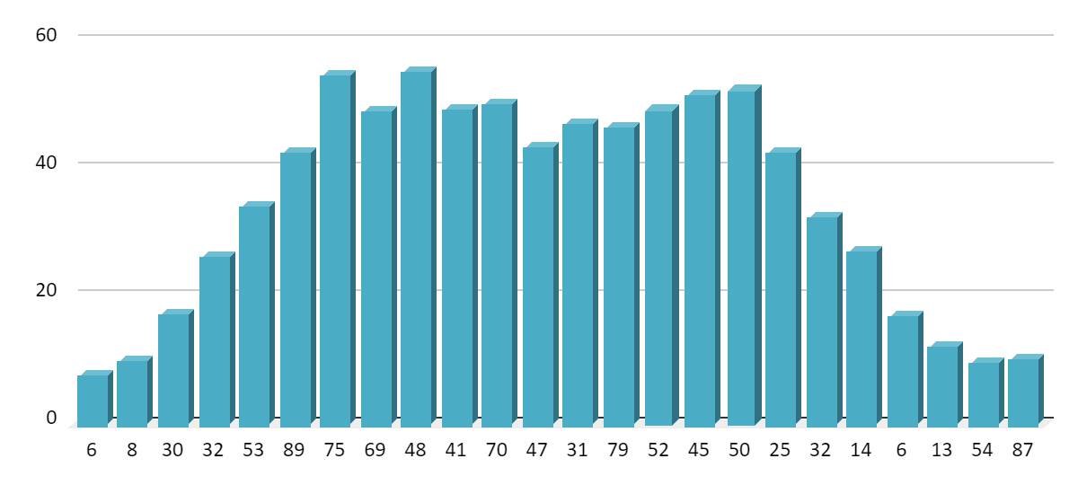

The chart presented shows the average hourly traffic on the Y-axis and the hours of the day on the X-axis.

**Key Insights from the Data:** Daily traffic peaks at 6 AM and stays within a consistent range until 4 PM (16:00), after which it begins to decline. As a result, the time frame from 6 AM to 4 PM is crucial for the business and should be managed by highly skilled professionals to ensure high customer satisfaction.

**Suggestions:**

* **Flexible Staffing:** Consider utilizing part-time, on-demand, or freelance agents during peak periods. Having a reserve pool of trained agents will help manage the workload without increasing permanent staffing costs.
* **Shift Optimization:** Adjust agent shifts to align with peak traffic times, ensuring sufficient coverage during high-demand hours.

**Analysis Process:**

* Extracting the hours from the creation date using the Right and Left functions.

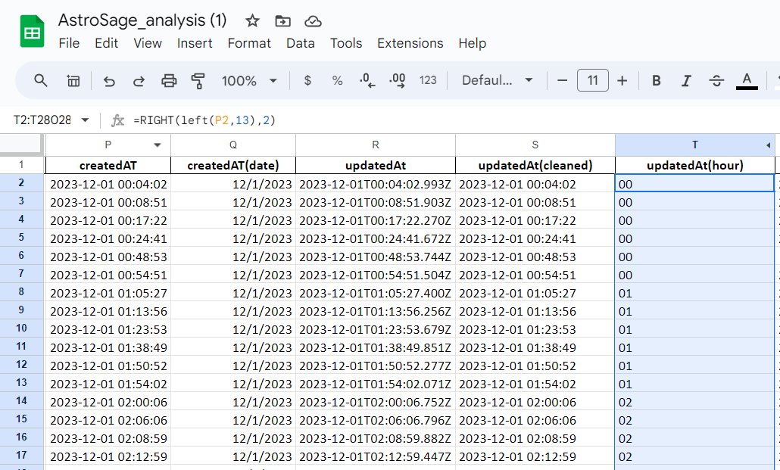

* Creating a pivot table to summarize the data of hourly volume v/s day

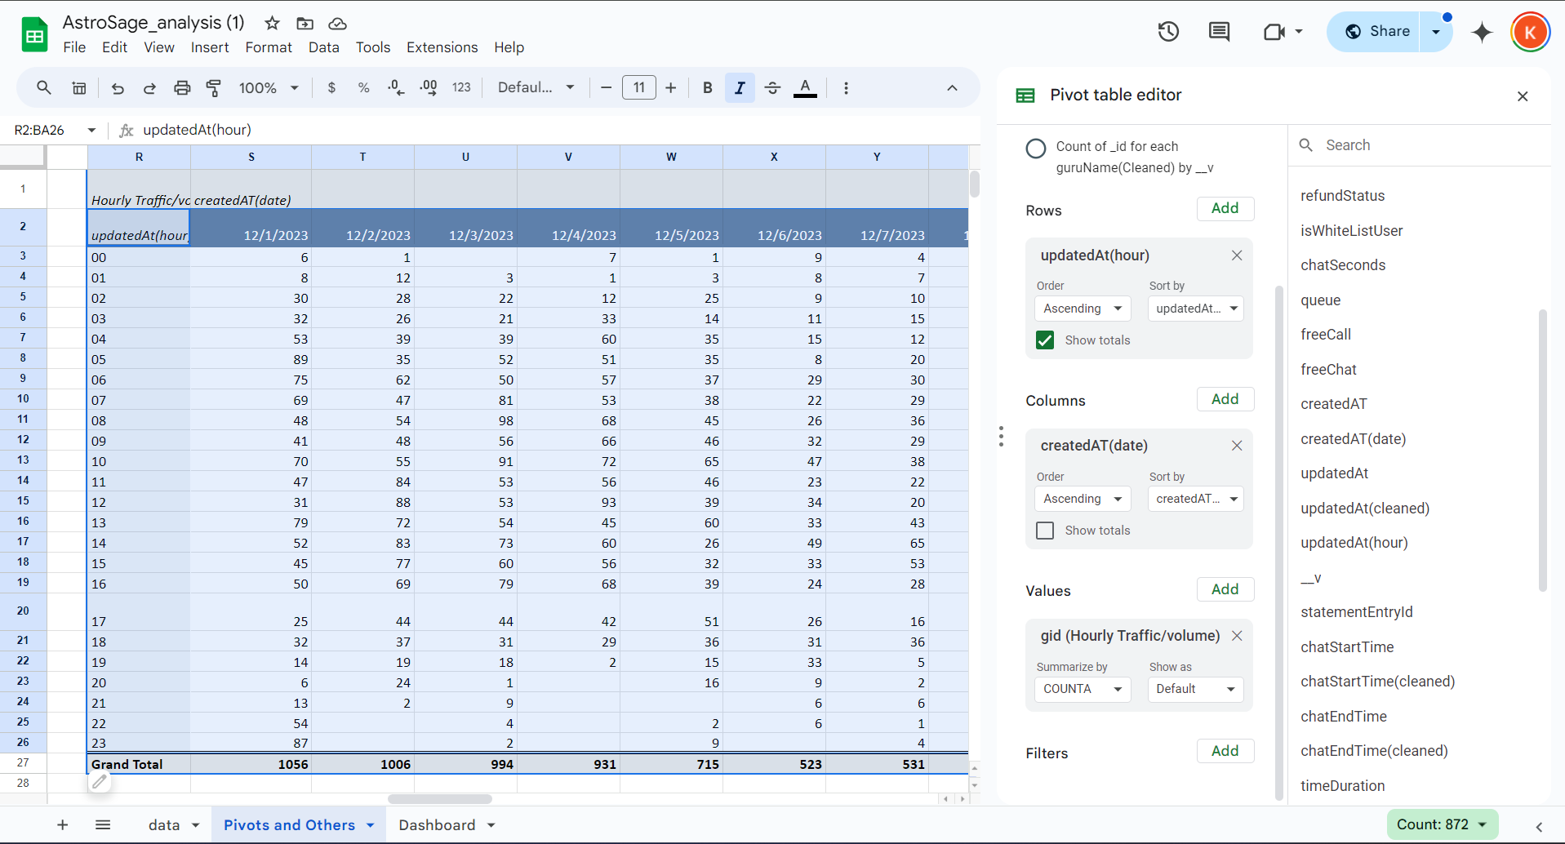

* Calculating the average of hourly traffic/volume.

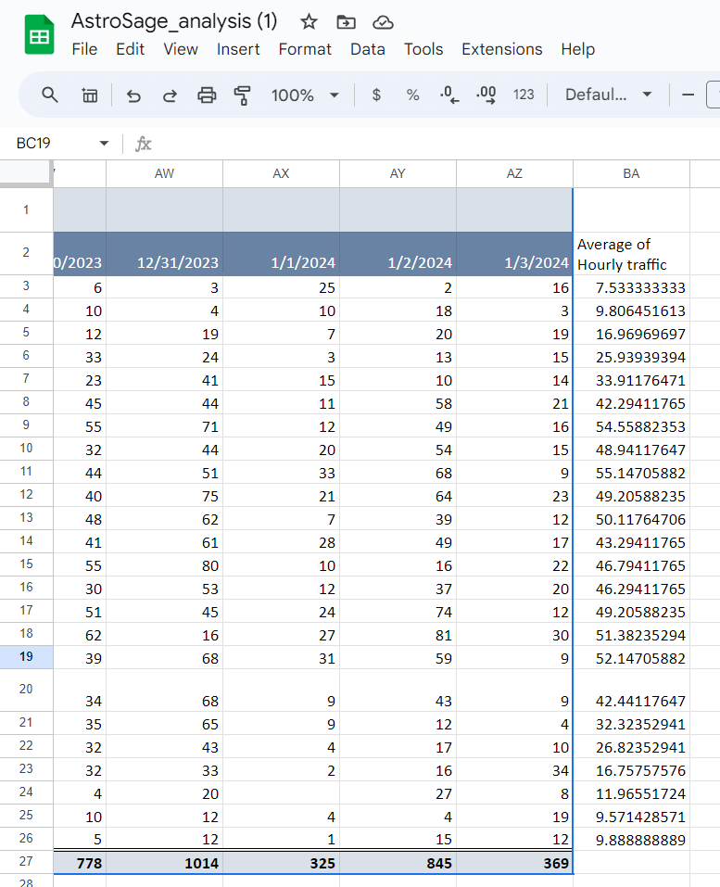

* Creating a column chart to visualize the hourly traffic

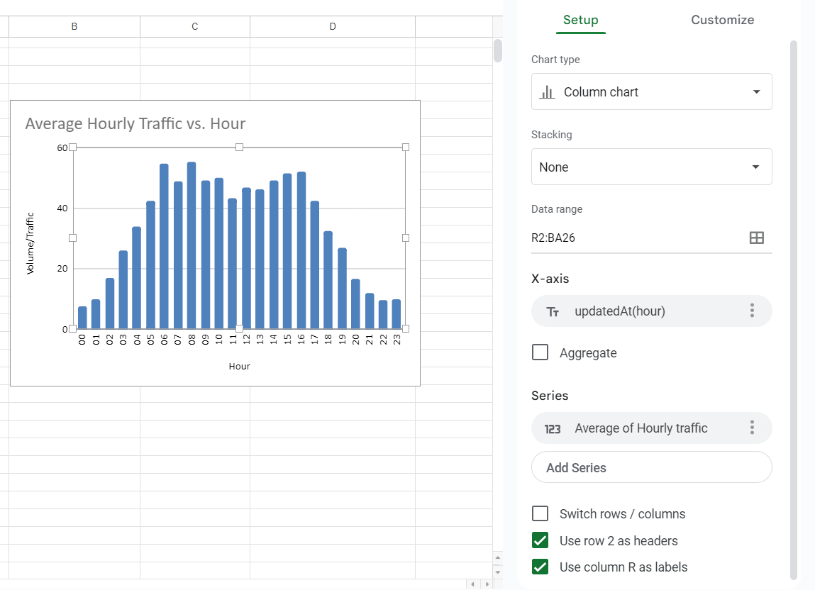

**5.** Based on historical data, what strategic initiatives should be prioritized to improve efficiency and customer satisfaction?

**Ans-**  Based on historical call center data and the objective of enhancing overall efficiency and customer satisfaction, the following strategic initiatives should be prioritized:

1. **Targeted Training for Underperforming Agents** Historical data will likely reveal certain agents with high failure rates and low customer ratings. Targeted training can significantly improve their performance, reduce call failures, and boost customer satisfaction.

**Action Plan:**

* Identify agents with low ratings and high failure rates.
* Develop tailored training sessions focused on areas such as communication skills, problem-solving, and technical knowledge.
* Evaluate performance improvements post-training to assess the effectiveness of the training program.

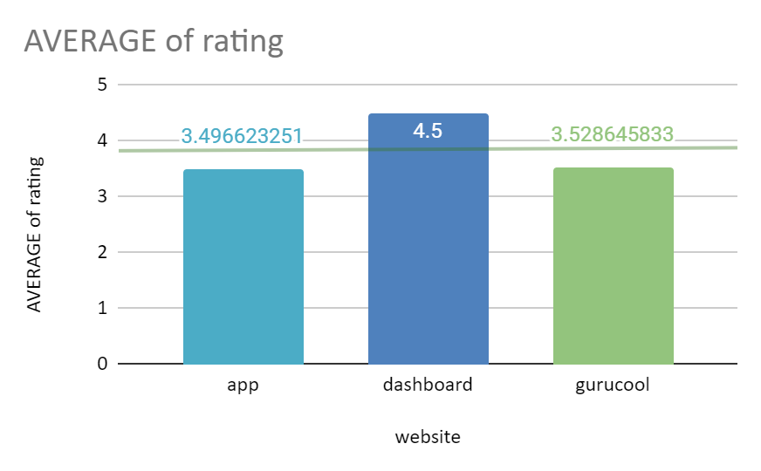

The provided image illustrates the distribution of ratings across the websites. It is evident that most of the data is concentrated on the left side, indicating lower customer satisfaction.

**2. Enhanced Call Management and Prioritization** Inefficient call routing causes longer wait times, leading to customer dissatisfaction, and may result in agents being misallocated. Intelligent call routing systems can better match customer needs with the appropriate agents.  
 **Action Plan:**

* Implement skill-based routing to direct calls to agents best equipped to handle them.
* Introduce priority queuing to ensure valued or returning customers receive faster service, particularly during peak hours.
* Regularly review and update routing rules based on performance reports.

**3. Strategies to Reduce Call Failures from Technological Limitations** **Rationale:** Past call data may reveal issues like call failures or technical difficulties that frustrate customers. Upgrading call center technology can improve call quality, reduce failures, and boost overall efficiency.  
 **Action Plan:**

* Invest in more reliable communication infrastructure with greater capacity to support smooth operations.
* Enhance or implement advanced IVR systems to handle routine calls, reducing the burden on agents.
* Utilize monitoring and diagnostic tools to identify and address technical issues as they arise.

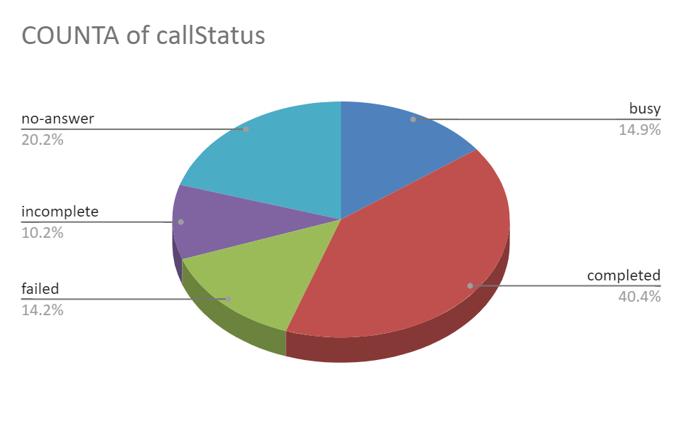

The Given Chart shows the failure rate of calls

4. Enhanced Self-Service Options  
 Customers can now resolve most of their common inquiries through self-service options. This helps reduce the volume of calls during peak hours by utilizing self-service channels like IVR, chatbots, and online portals.  
 Action:  
 Develop and integrate advanced IVR systems to address a wider range of customer queries that do not require agent assistance.  
 I recommend implementing AI-powered chatbots to assist customers with simpler issues they may encounter.  
 Encouraging customers to use self-service tools increases their effectiveness in accessing information and interacting with the system.

Conclusion: Focusing on targeted training, technological advancements, improved call routing, and workforce optimization based on historical data will greatly enhance overall efficiency and customer satisfaction.

___________________________________________________________________

**Q6.**What can be the key factors contributing to high customer satisfaction scores, and how can these be leveraged to improve overall performance?

What is the basis for the suggestions? And mention how did you decide if the satisfaction score affect the ratings?

**Ans-**

The key factors contributing to the high customer satisfaction scores are:

Agent Interaction:  
 Customer satisfaction is significantly influenced by agents who are in high demand and possess advanced expertise.

Low Call Volumes:  
 Customer experience improves when agents manage fewer calls, allowing for more personalized consultations and higher ratings. When agents are overwhelmed with calls, their efficiency and customer ratings tend to decline.

Performance Improvement Strategies:  
 Agents who are well-trained and manage lower call volumes can deliver better results, leading to higher customer satisfaction. Effective training and optimized workload management are key to improving performance.

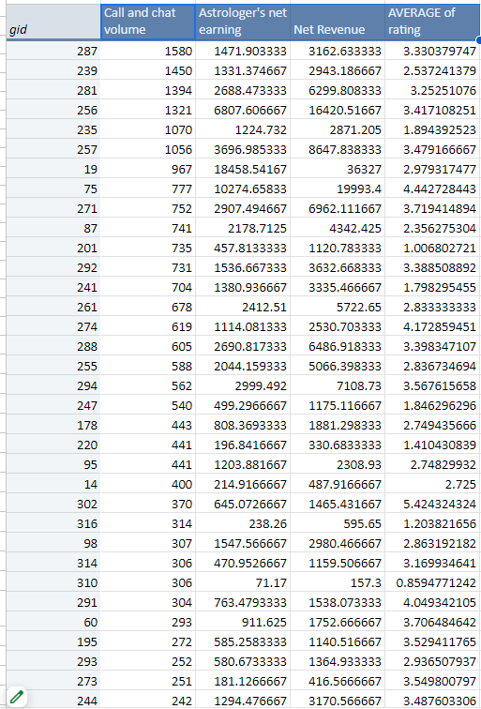

The performance of the agents and their ability to handle the customers is revealed by this pivot table. This part of the table shows us the top agents that manage the most volume of calls.

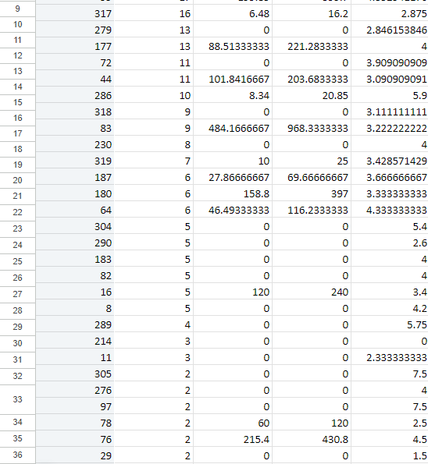

The bottom of the table highlights agents with poor performance in terms of call volume or handling efficiency.

It is important to prioritize customer needs when distributing interactions, ensuring they are balanced and assigned to the appropriate agents.

___________________________________________________________________

**Q7.**How should the call center balance the workload among agents to ensure optimal performance and avoid burnout?

Mention your approach and spreadsheet function for the answer?

**Ans-**

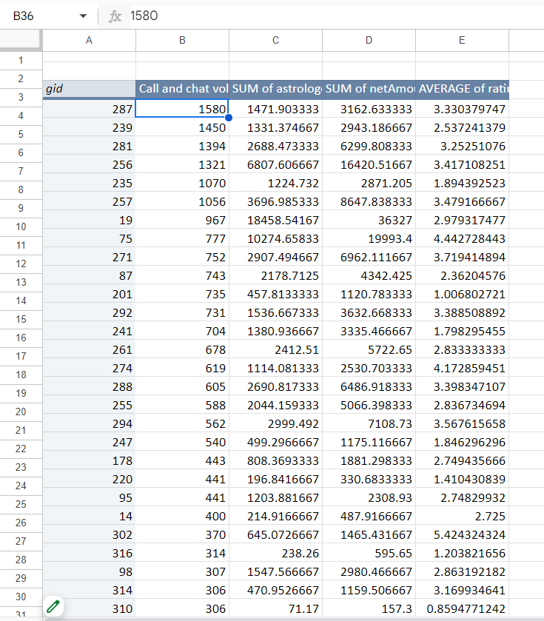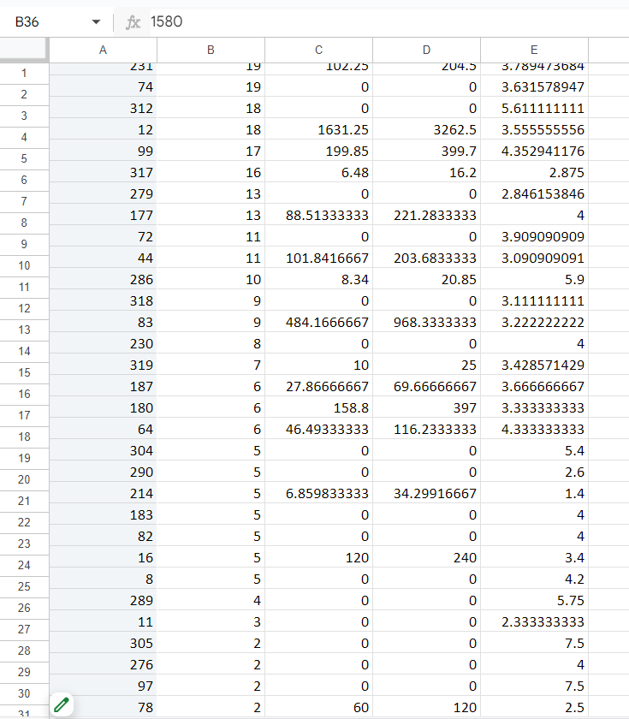

Below is the pivot table displayed on the dashboard. The second column represents the number of queries (both calls and chat requests) received by the agents. The distribution of these queries among the agents is uneven, with some agents being overutilized while others are significantly underutilized. This imbalance can lead to agent exhaustion, decreased productivity, or even agents seeking other opportunities.

**Action:** By analyzing historical call data, we can predict peak periods and schedule employees accordingly, ensuring that adequate personnel are available during busy hours.

Introducing shift work can also help prevent agents from consistently working during high-stress periods. Rotating shifts ensures that different team members handle the workload, maintaining balance.

Additionally, implementing skill-based routing will direct calls to agents with the relevant expertise. For example, complex or high-priority calls should be handled by experienced agents, while simpler queries can be assigned to newer or less experienced agents.

Providing mental health services and support tools is essential to help agents cope with stress, reducing the risk of burnout.

Finally, real-time performance monitoring tools should be used to track call handling times, queue lengths, and agent workloads. If an agent is overwhelmed with an excessive number of calls, managers can adjust the call distribution to ensure a more even workload.

___________________________________________________________________

**8.** What new technologies or tools could be implemented to enhance call center operations and customer service?

**Ans-** Improving call center management and customer relations can be achieved by integrating proactive technologies and tools that enhance management, productivity, and customer satisfaction. Below are some innovative technologies and tools that can be implemented:

1. AI and Machine Learning  
     
    AI-Powered Chatbots:  
    AI-driven chatbots can handle simple inquiries and manage customer interactions, reducing call traffic for agents. NLP-based chatbots can provide human-like responses and resolve most issues without needing human intervention.  
     
    Tool Examples: IBM Watson, Google Dialogflow, Zendesk Answer Bot.
2. Robotic Process Automation (RPA)  
     
    Task Automation:  
    Routine tasks such as data entry, updating customer databases, and processing refunds can be automated, freeing up agents to focus on more complex interactions. This boosts service efficiency and allows agents to concentrate on higher-value tasks.  
     
    Tool Examples: UiPath, Automation Anywhere, Blue Prism.
3. Cloud-Based Call Center Solutions  
     
    Scalability and Flexibility:  
    Cloud-based call center platforms offer scalability, allowing easy customization as the business grows. These platforms also support remote work, providing staffing flexibility and ensuring business continuity during disruptions.  
     
    Tool Examples: Amazon Connect, Twilio Flex, RingCentral.
4. Customer Relationship Management (CRM) Integration  
     
    360-Degree Customer View:  
    Integrating the call center with a CRM system allows agents to access comprehensive customer data, including past interactions, orders, and preferences. This enables personalized service and more relevant interactions with each customer.  
     
    Tool Examples: Salesforce, HubSpot CRM, Microsoft Dynamics 365

___________________________________________________________________

.

**Q9.**What metrics should be included in the final dashboard to provide a comprehensive view of call center performance and guide investment decisions?

**Answer:** 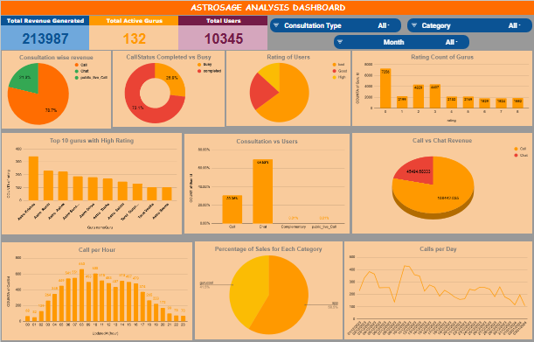

Metrics to be included in the final dashboard to optimize business performance and identify any underlying issues could include the following filters and related metrics:

Filters:

* Consultation Type Filter
* Platform Filter (Website or App)

Metrics affected by these filters:

* Total Revenue Generated: This metric shows the total revenue the business generates across all activities. It can be filtered by consultation type (call, chat, or both) and platform (app, website, or both), offering insights into overall performance.
* Total Active Gurus/Agents: This measures the workforce available to serve customers. It can be filtered using the available options to track performance by consultation type or platform.
* Daily Active Users: This metric visualizes daily user activity across different platforms (app, GuruCool, etc.). It is useful for tracking the volume of users engaging with the business daily and identifying trends or changes in performance.
* Daily Activity on Astrosage: This chart tracks overall daily activity across the platform and can be filtered to analyze the specifics of different business segments.
* Activity vs. Revenue: This metric compares the total activity levels with revenue generated from different consultation types (e.g., call, chat). It helps analyze the income generated from users with varying consultation preferences.
* One-Time vs. Repeat Users: This chart displays the percentage of repeat users, which is crucial for understanding customer retention. A healthy proportion of repeat users is essential for business sustainability.
* Platform Activity Overview: This shows the distribution of user activity across various consultation types (chat, call, etc.), providing insights into user preferences and platform engagement.
* Average Rating Distribution: A key metric for assessing the overall health and performance of the business, this distribution reveals how customers perceive the service. It offers actionable insights for improving customer satisfaction and service quality.

___________________________________________________________________

**Q10.**How would you allocate a 1 crore rupee investment to optimize operational efficiency, enhance customer satisfaction, and boost profitability, and what analysis-based recommendations would you offer to support this?

[you have to give bullet pointers in order to answer this question]

**Answer:**

1. **Technology Upgrades (Rs. 40 Lakhs)  
    Recommendation: Invest in advanced call distribution systems, AI-driven chatbots, and CRM tools.  
    Rationale:  
    Upgrading technology will enable efficient call routing during peak hours, balance agent workloads, and reduce customer wait times. AI-based tools can assist agents with complex cases while handling routine inquiries independently. Integrating these technologies into the CRM will enhance tracking and provide more personalized customer service.  
    Expected Impact:**
   * **Operational Efficiency: Improved response times and reduced agent burnout.**
   * **Profitability: More efficient call and chat handling, leading to increased revenue.**
2. **Training Programs (Rs. 25 Lakhs)  
    Recommendation: Provide targeted training in communication, problem-solving, product knowledge, and more.  
    Rationale:  
    While chats drive high customer engagement, they generate low revenue. Improving communication skills and focusing on conversions will enhance the effectiveness of these interactions. Additionally, upskilling agents to manage complex queries will reduce resolution time and improve customer satisfaction.  
    Expected Impact:**
   * **Customer Satisfaction: Higher-quality interactions lead to better ratings and more repeat customers.**
   * **Profitability: Improved upselling and cross-selling opportunities during customer interactions.**
3. **Additional Agents (Rs. 20 Lakhs)  
    Recommendation: Increase the number of agents to avoid backlog and long wait times during peak periods.  
    Rationale:  
    Current agents are overwhelmed during busy times, resulting in prolonged wait times and dissatisfied customers. Adding new agents will help balance workloads and reduce wait times, ensuring quicker support for customers.  
    Expected Impact:**
   * **Operational Efficiency: Reduced average waiting times for calls and chats.**
   * **Customer Satisfaction: Faster query resolution, improving the overall customer experience.**
4. **Customer Retention Strategies/Marketing (Rs. 15 Lakhs)  
    Recommendation: Allocate funds for customer retention programs (e.g., loyalty points, personalized offers) and marketing efforts.  
    Rationale:  
    Data suggests that tailored loyalty programs can boost customer satisfaction and loyalty. Investing in these programs, along with marketing, can strengthen customer retention.  
    Expected Impact:**
   * Customer Satisfaction: Personalization through offers and feedback-based improvements.
   * Profitability: Retaining customers ensures steady revenue and reduces acquisition costs.

___________________________________________________________________

